
Submitted By:
Muhammad Najeeb Subah (2025-CE-91)
Assignment:
Circuit analysis lab
Submitted To:
Sir mehmood
For the fulfillment of,
Circuit analysis lab
Department of Computer Engineering
University of Engineering and Technology, Lahore

Objective
The objective of this lab is verify Nortan’s theorem and to find the full load current.
Apparatus Required
Sr. no Apparatus Range Quantity
1 Regulated Power Supply Standard 1
2 Signal Generator Standard 1
3 Oscilloscope Standard 1
4 Digital Multimeter Standard 1
5 Breadboard & Wires Standard As Required
6 Resistors 1k, 330 ohms 1,3
7 Potentiometer Standard 1
Description
Statement:
Any linear circuit can be simplified to an equivalent circuit consisting of a single
current source and parallel resistance that is connected to a load.
Precautions:
1. Voltage control knob of RPS should be kept at minimum position.
2. Current control knob of RPS should be kept at maximum position
Procedure for Norton’s Theorem:
1. Connections are given as per circuit diagram.
2. Set a particular value in RPS and note down the ammeter readings in the original
circuit.
To Find IN:
3. Remove the load resistance and short circuit the terminals.
4. For the same RPS voltage note down the ammeter readings.
To Find RN:
5. Remove RPS and short circuit the terminal and remove the load and note down the resistance
across the two terminals.
Equivalent Circuit:
6. Set IN and RN and note down the ammeter readings.
7. Verify Norton’s theorem.
To find load current in circuit 1:
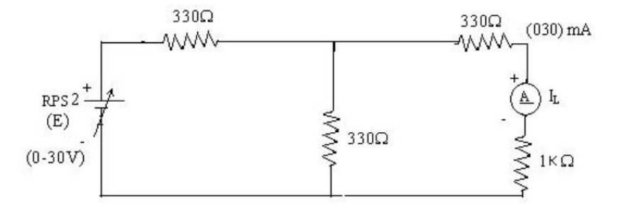

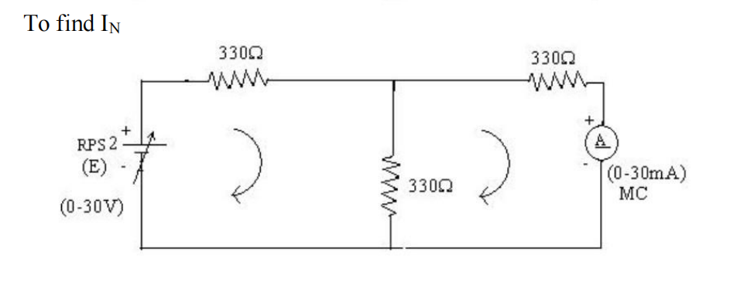
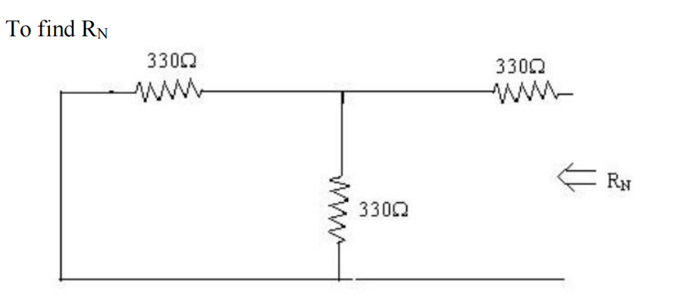

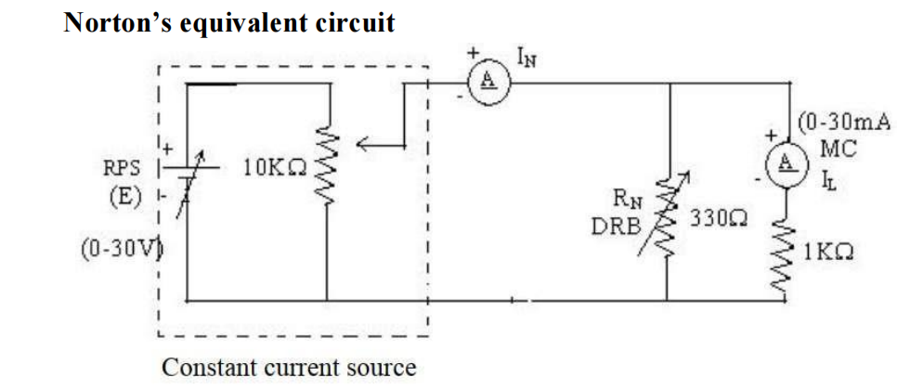
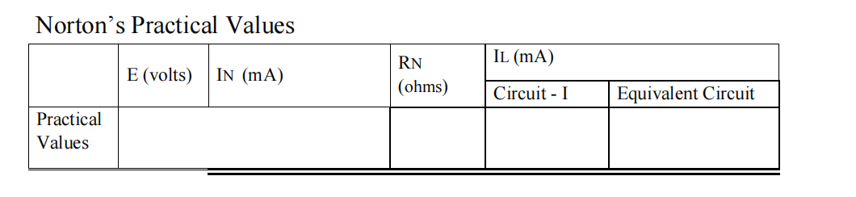

15.15 495 5.02 5.02

